**IRT Assembly**

Tools:

* Drill
* ¼” spade bit (Used for drilling hole in canopy sensor cap)

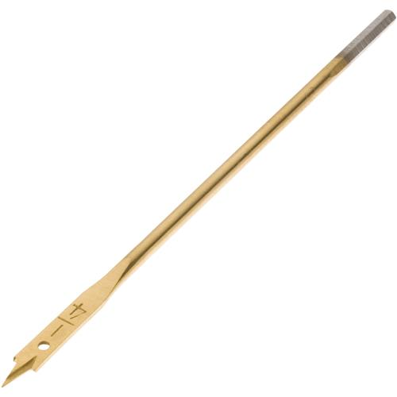

* 3/16” drill bit (used for holes in t-pvc)
* Impact Driver
* 5/16” magnetic nut driver

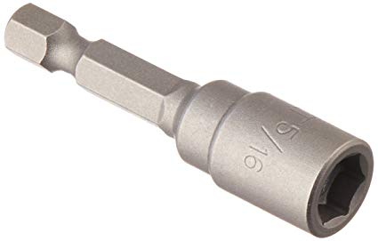

* Chop saw (for cutting PVC)
* Table vice clamp:

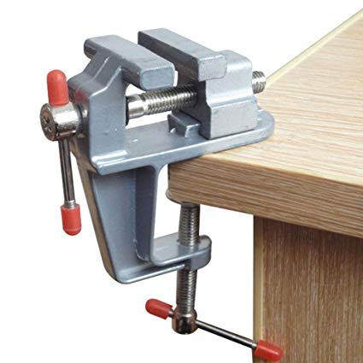

Materials:

|  |
| --- |
| 35 degree IRT sensor |
| 90 degree IRT sensor |
| 12V battery |
| Gray Conduit PVC (~7ft, ~1.25" dia) |
| PVC tee reducer (1 1/4 x 1 1/4 x 3/4") |
| PVC elbow (1 1/4") |
| 90 degree 3/4" elbow |
| 3/4" caps |
| 3/4" PVC |
| Zinc-plated round ceiling type screw #8 |
| Metal pole |
| Cable (4c22) |
| Plastic tubing (ID 3/8", OD 1/2") |
| 12 gauge solid THHN wire (insulated) |
| PVC reducing tee (1 1/4" x 1 1/4" x 1") |
| 1" Elbow |
| 3/4" PVC cap |
| 1" PVC |
| Solar Panel and mount |
| Charge Controller |
| Enclosure |
| Battery Enclosure |
| Cable (2c22) |
| Zip ties |
| Desiccant packs |
| #12 x ½” Self-driving screws |
| Washer (1/4") |
| Washer (3/8") |
| 36" Plant prop |

Power cables:

* From charge controller to each IRT setup (Qty 14)
* From solar panel to charge controller (Qty 8)
* From battery to charge controller (Qty 8)